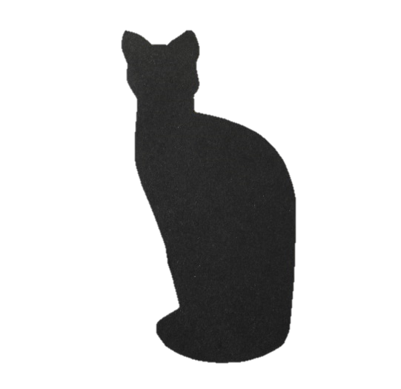

**WORLDHAM COUNTRY CATTERY**

Booking Form

*The following information is required for bookings to be accepted.

Owners Name *:

Address*:

Postcode*:

Tel*: Mobile*:

Email address*: Preferred contact: Email/telephone

Emergency contact*: (while your cat(s) are boarding):

Name*:

Address:

Postcode*:

Tel*: Mobile*:

Email address*:

Boarding from*: / / to / /

|  |  |  |  |  |
| --- | --- | --- | --- | --- |
| Cats Name |  |  |  |  |
| Breed |  |  |  |  |
| Colour  Distinguishing  marks |  |  |  |  |
| Sex/neutered |  |  |  |  |
| Age |  |  |  |  |
| Microchip |  |  |  |  |

Diet.

Wet food brand*:

Dry food brand*:

Special diet*:

Treats*: Yes /No Please select from our feline favourites menu below.

Health.

Usual veterinary practice*:

Name*:

Address*:

Telephone number*:

Email address*:

Vaccinated*: Yes / No Booster due*:

Vaccination certificates must be provided for each cat.

Flea treated*: Yes / No Date*:

Product used*:

Wormed*: Yes/No Date*:

Product used*:

Current medications*:

Insured*: Yes/ No Insurance company*:

Notes: any other information it would be helpful to know.

e.g. Disabilities, previous urinary issues, unusual behaviours etc

Handling.

Play*: Yes/Shy

Grooming*: Enjoys/Dislikes

In order for your cat(s) stay to be as enjoyable and stress free as possible it is helpful to have the following information about your feline friend(s).

The Feline Favourites Menu. (a selection of treats available to those allowed)

Freshly prepared: Chicken White fish Tuna Prawns

Milk : Normal Cat

Dreamies Lick-e-lix Dentabits Whiskas temptations

Soups Felix goody bag selection

Litter tray preferred: Open Lid

Litter type preferred:

Water Fountain (especially for those who have had previous urine problems but available to all).

Cat flap: (used to using) Yes/ No

Availability will be confirmed on receipt of this form and the booking confirmed on receipt of the deposit.

Please read the terms and conditions carefully.